Last Updated: 12/10/2020
This QRG is used to document projected work hours on the timesheet. This is helpful when payroll-processing time is shortened due to campus closing, such as Winter Recess. Regardless if the employee is on a positive or negative time profile – they will need to enter their estimated hours when payroll is processed early. Employees using the Webclock will provide their estimated hours to the supervisor, who can then enter the time on the timesheet in SuccessFactors.

Access SuccessFactors
- Visit OneCampus at https://one.purdue.edu/ and select Employee Launchpad.  - Log in using Purdue Career Account ID and BoilerKey passcode. | 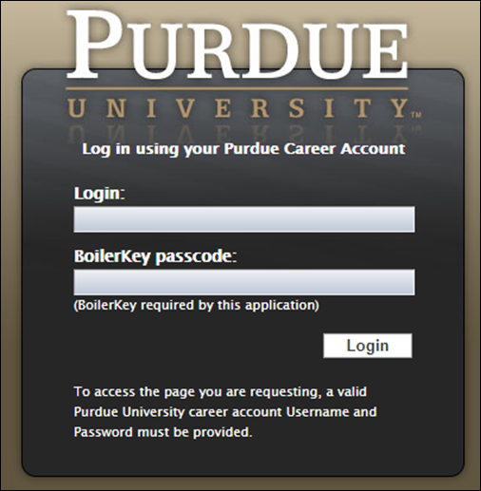

Access Timesheet and Complete
If you hold multiple positions, use the Change Selected Employment menu to select the position for which you would like to record time | 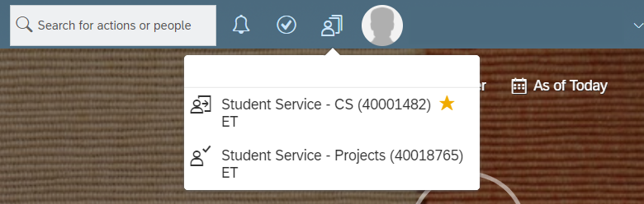
(  Click the Time Sheet tile. | 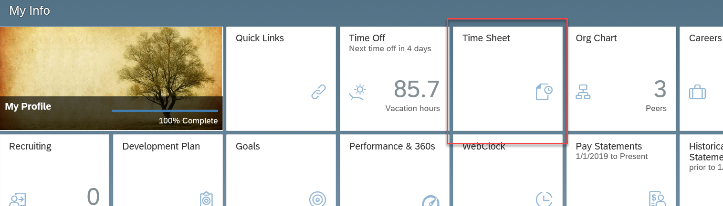
The current week’s timesheet opens. | 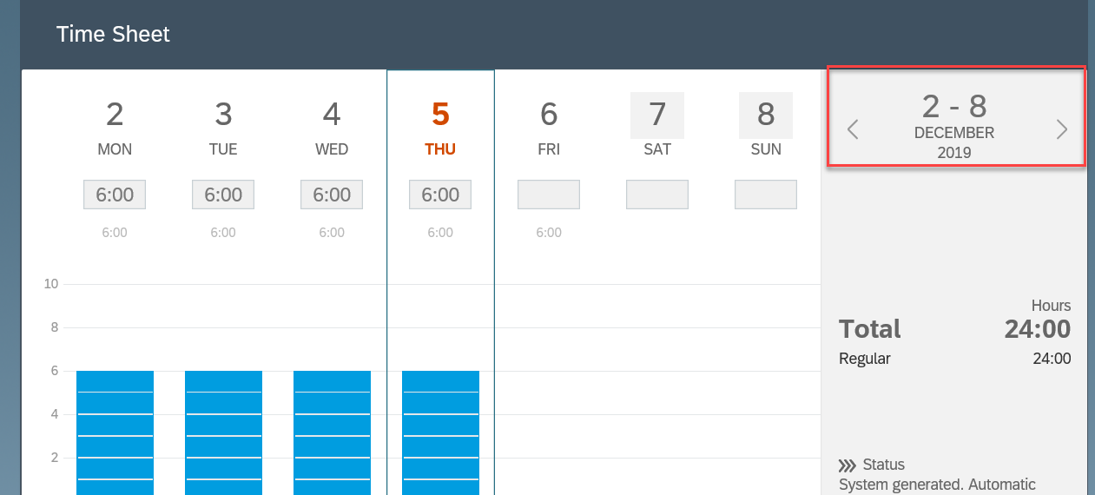
Navigate to the desired timesheet by clicking the next (right) arrow on the date range. | 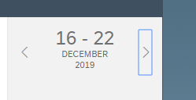
Enter projected time for that week on each day under the DETAILS section towards the bottom of the page. Select Working Time as Time Type and type number of hours in Duration.
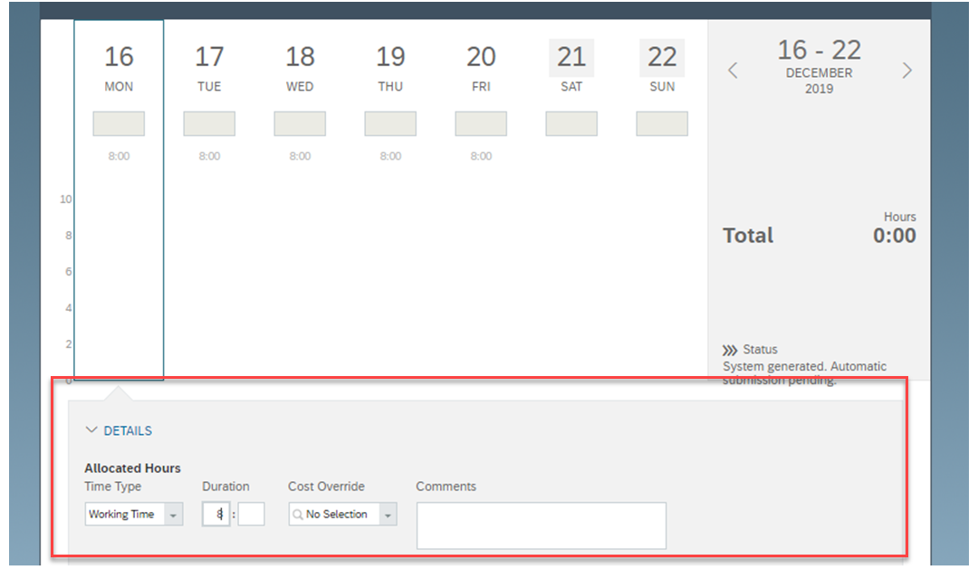

Click Save to save the changes. The Save button will gray-out once the timesheet is saved. If the timesheet is not saved – the hours will not be paid.
